EXPERIMENT NO. 10
LEXICOGRAPHICALLY SMALLEST STRING BY SWAPPING TWO CHARACTERS USING RAPTOR

AIM
To draw and validate a RAPTOR flowchart that, for a given string of lower-case letters, chooses two characters and swaps all their occurrences at most once, so that the lexicographically smallest string is obtained.
SOFTWARE / TOOLS REQUIRED
- RAPTOR
- Windows PC
PROCEDURE
Step 1: Launch RAPTOR
- Open the RAPTOR software from the desktop or Start menu.
- Create a new flowchart by selecting File → New.
- The flowchart initially contains only the Start and End symbols.
Step 2: Insert Input Symbols
- Add three Input symbols between the Start and End symbols.
- Read the required inputs from the user:
- Input the string (str).
- Input the first character (ch1) to be swapped.
- Input the second character (ch2) to be swapped.
- These inputs are required to perform the character swapping operation.
Step 3: Initialize Variables
- Insert an Assignment symbol after the input symbols.
- Initialize the variables required for processing the string.
- Set the loop counter to the first character of the string:
i ← 1

- Find the total number of characters in the string:
n ← Length_Of(str)

- These variables help in traversing the entire string.
Step 4: Create a Loop for String Traversal
- Insert a Loop symbol after the assignment symbol.
- Specify the loop condition:
i <= n

- The loop ensures that every character in the string is examined one by one until the last character is reached.
Step 5: Compare the Current Character with the First Selected Character
- Inside the loop, insert a Selection symbol.
- Compare the current character of the string with the first selected character (ch1).
- If the comparison is true, replace that character with the second selected character (ch2).
- If the comparison is false, proceed to check the second character.
Step 6: Compare the Current Character with the Second Selected Character
- Insert another Selection symbol.
- Compare the current character with the second selected character (ch2).
- If they are equal, replace that character with the first selected character (ch1).
- Otherwise, retain the character without making any changes.
- This step completes the swapping of the selected characters throughout the string.
Step 7: Increment the Loop Counter
- Insert an Assignment symbol after the comparison process.
- Increase the loop counter by one:
i ← i + 1

- Connect this symbol back to the loop condition so that the next character is processed.
Step 8: Display the Modified String
- Once the loop terminates, insert an Output symbol.
- Display the modified string obtained after swapping all occurrences of the selected characters.
- This string represents the resulting string after performing the operation once.
Step 9: Validate the Flowchart
- Execute the flowchart using the Run option available in RAPTOR.
- Enter sample input values when prompted.
- Verify whether the output matches the expected result.

OUTPUT
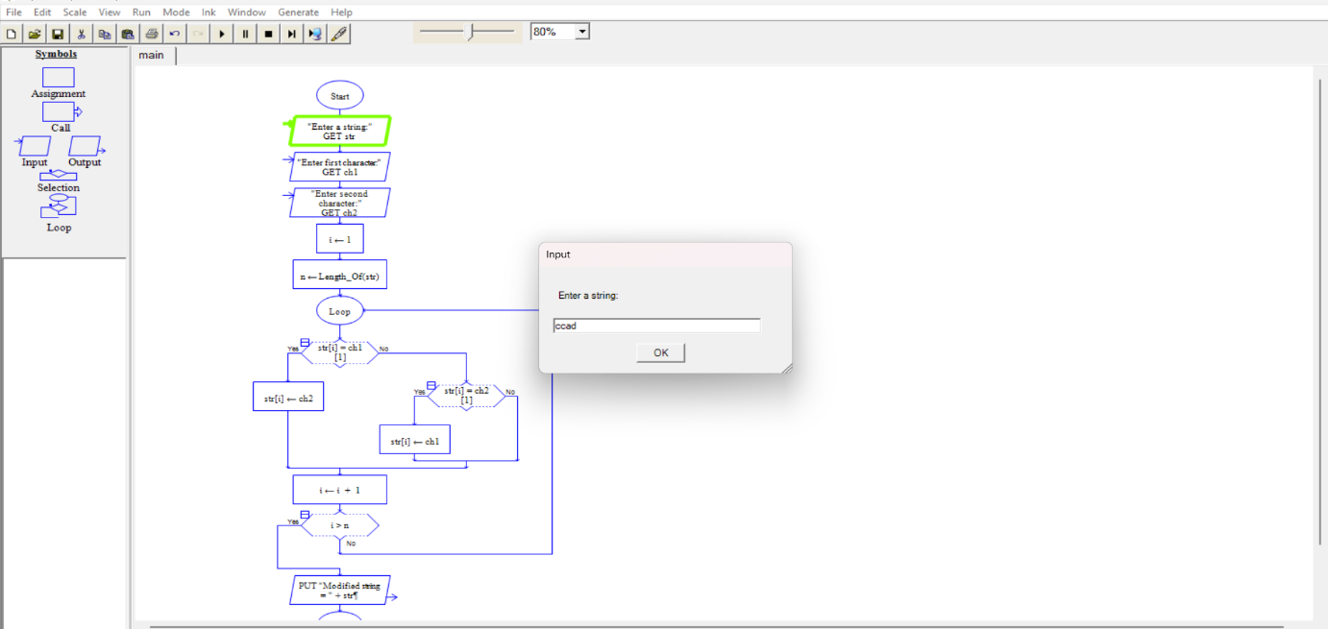

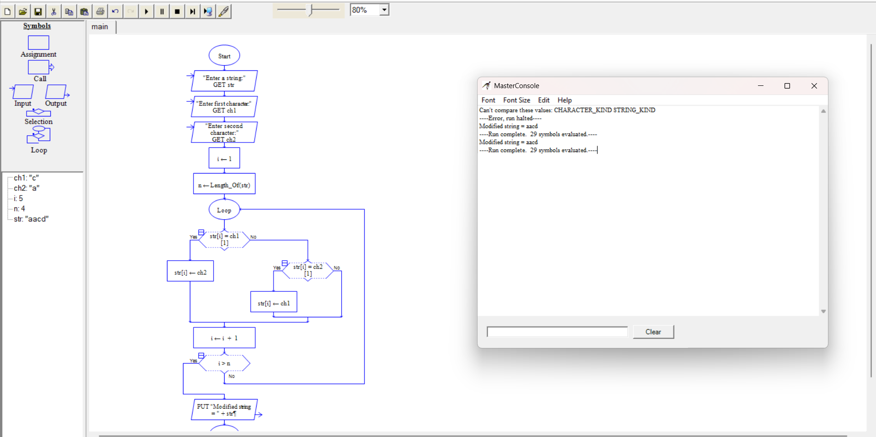

EXPECTED OUTPUT
- Input: str = ccad, ch1 = c, ch2 = a
- Output: Modified string = aacd
RESULT
Thus the flowchart to obtain the lexicographically smallest string by swapping all occurrences of two characters at most once was drawn and validated using RAPTOR.

